mixing distribution

Intro

Mixing distribution refers distribution with a random variable which is derived from a collection of different kinds of random variables.

First, select a random variable by chance among the collection of random variables.

Second, realize the value of the selected random variable.

PDF

Uncountable mixtures

If the mixtures is uncountable, I.e. one can NOT say 1,2,…

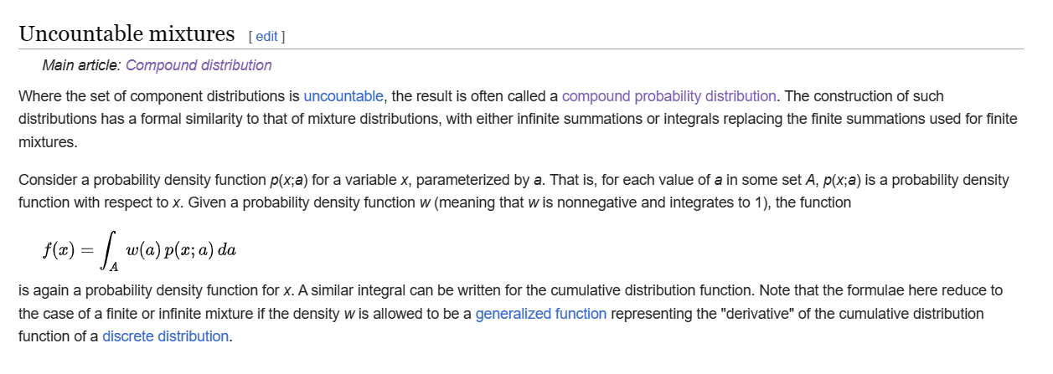

Countable and Finite mixtures

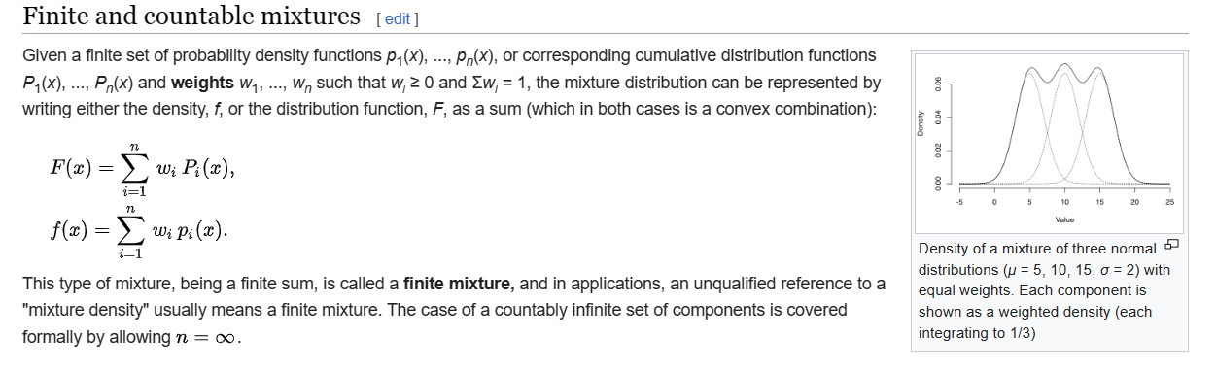

CDF

Countable and Finite mixtures



Mode

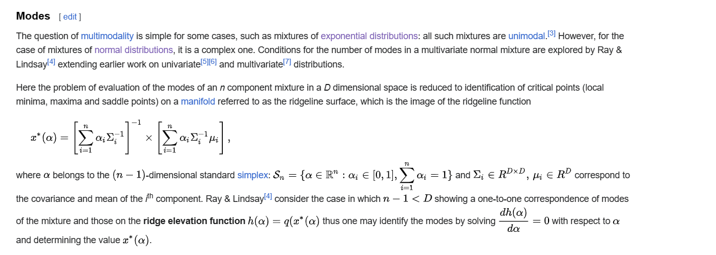

Moment

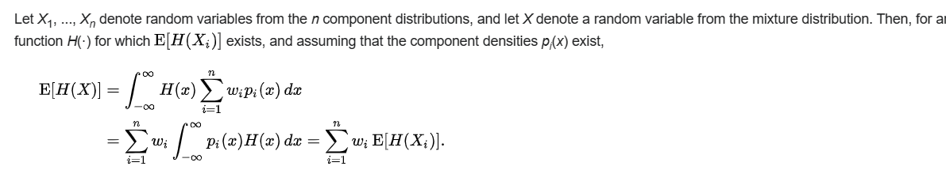

Central Moment

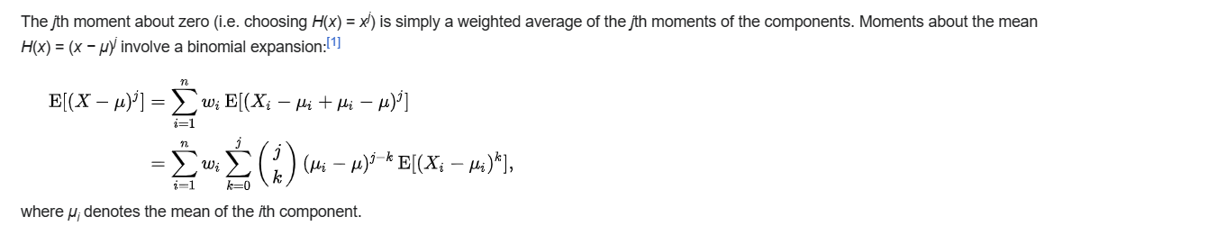

Ref

[Mixture distribution - Wikipedia](https://en.wikipedia.org/wiki/Mixture_distribution)